**Maximum Rectangular Area in a Histogram**

Find the largest rectangular area possible in a given histogram where the largest rectangle can be made of a number of contiguous bars. For simplicity, assume that all bars have the same width and the width is**1 unit**, there will be **N** bars height of each bar will be given by the array **arr**.

**Example 1:**

**Input:**

N = 7

arr[] = {6,2,5,4,5,1,6}

**Output:** 12

**Explanation:**

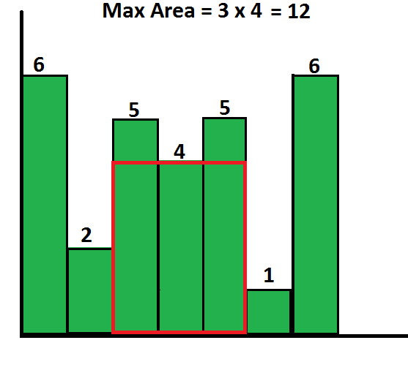

**Example 2:**

**Input:**

N = 8

arr[] = {7 2 8 9 1 3 6 5}

**Output:** 16

**Explanation:** Maximum size of the histogram

will be 8  and there will be 2 consecutive

histogram. And hence the area of the

histogram will be 8x2 = 16.

**Your Task:**  
The task is to complete the function **getMaxArea**() which takes the array arr[] and its size N as inputs and finds the largest rectangular area possible and **returns** the answer.

**Expected Time Complxity** : O(N)  
**Expected Auxilliary Space** : O(N)

**Constraints:**  
1 ≤ N ≤ 106  
1 ≤ arr[i] ≤ 1012